**Sprint Plan 3:**

**Heading:**

* Document name: "Sprint 3 Plan"
* Product name: Sandwich Story
* Team name: “The Sandwich Guys”
* Sprint Completion date: July 24th, 2017
* Revision number: Revision 1
* Revision date:July 17th, 2017

**Goal:**

Make the user experience while using the app smooth with unique aesthetics and minimal bugs and/or quirks that need ironing out.

**Task listing, organized by user story:**

* User Story 1: As a user, I would like to be able to have a stable database to store and search for sandwiches so that I can be connected with the users of the Sandwich Story app
  + Task 1: Figure out how to debug the backend code for easy editing (6 ideal hours)
  + Task 2: Finish the pop_downloads and add_sandwich function and make sure every function works well with the library (5.5 ideal hours)

**Total for user story 1: 11.5 ideal hours**

* User Story 2: As a user, I’d like to be able to search for recipes based on keywords so I can easily find recipes I’m looking for.
  + Task 1: Add search bar to the xml file (1 ideal hour)
  + Task 2: Write code that properly searches based on the user’s entered keyword(s) (5 ideal hours)

**Total for user story 2: 6 ideal hours**

* User Story 3: As a user, I would like to use a smooth, bug-free application.
  + Task 1: Isolate the bug in the code that is causing the list of ingredients to appear out of order (3 ideal hours)
  + Task 2: Fix this bug and restore the ingredients to proper viewing order (2 ideal hours)
  + Task 3: Use/test the application to detect any other bugs to be fixed (2 ideal hours)

**Total for user story 3: 7 ideal hours**

* User Story 4: As a user, I want to have an app that is aesthetically pleasing so that I will have an even better experience using the app
  + Task 1: Add unique backgrounds to the app for each activity/page (4 ideal hours)
  + Task 2: Change up the fonts to be less boring to read (2 ideal hours)
  + Task 3: Add sounds to the app for button presses and entering activities (4 ideal hours)

**Total for user story 4: 10 ideal hours**

**Team Roles:**

Alex Williamson - Product Owner, Front-End Developer, Backend Developer

David Stewart - Front-End Developer, Backend Developer

Chris Hahn - Front-End Developer

Celine Peña - Scrum Master, Front-End Developer

Davie Truong - Front-End Developer

Matthew Diep - Scrum Master, Front-End Developer

**Initial Task assignment:**

Alex Williamson - User Story 1: Task 1,2

David Stewart - User Story 1: Task 1,2

Chris Hahn - User Story 1: Task 2, User story 4: Task 1

Celine Peña - User Story 2: Task 1, User Story 3: Task 1,2,3

Davie Truong - User Story 3: Task 1

Matthew Diep - User Story 4: Tasks 1,2,3

**Initial Burnup chart:**

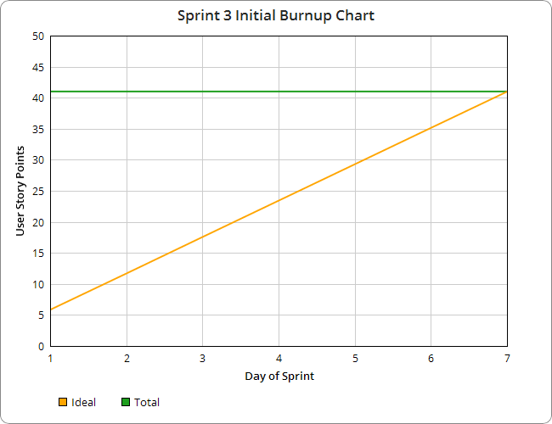

**Initial scrum board:**

|  |  |  |  |
| --- | --- | --- | --- |
| User Story | To Do | In Progress | Done |
| As a user, I’d like to be able to have a stable database to store and search for sandwiches so that I can be connected with the users of the Sandwich Story app | |  | | --- | | Figure out how to debug the backend code for easy editing |  |  | | --- | | Finish the pop_downloads and add_sandwich function, make sure every function works well with the library | |  |  |
| As a user, I’d like to be able to search for recipes based on keywords so I can easily find recipes I’m looking for. | |  | | --- | | Add search bar to the xml file |  |  | | --- | | Write code that properly searches based on the user’s entered keyword(s) | |  |  |
| As a user, I would like to use a smooth, bug-free application. | |  | | --- | | Isolate the bug in the code that is causing the list of ingredients to appear out of order |  |  | | --- | | Fix this bug and restore the ingredients to proper viewing order |  |  | | --- | | Use/test the application to detect any other bugs to be fixed | |  |  |
| As a user, I want to have an app that is aesthetically pleasing so that I will have an even better experience using the app | |  | | --- | | Add unique backgrounds to the app for each activity/page |  |  | | --- | | Change up the fonts to be less boring to read |  |  | | --- | | Add sounds to the app for button presses and entering activities | |  |  |

**Scrum times:**

* Tuesday 12:30-4:30pm
* Thursday 12:30-4:30pm (with Sohum)
* Friday 2:30 - 10:30pm
* Saturday 2:30-10:30pm
* Sunday 2:30-10:30pm